**TREASURED KID S NEST NURSERY AND PRIMARY SCHOOL**

**P.5 SCIENCE**

**Name:** __________________________________________________________________

**SECTION A**

1. Name the part of the plant that makes food.

____________________________________________________________________

1. Mention the intestinal worm that enters the body through the bare skin.

____________________________________________________________________

1. Give a reason why most of the farmers de-beak their layers.

____________________________________________________________________

1. Mention any one condition of weather you know.

____________________________________________________________________

1. Give the use of the garden tool below to people.

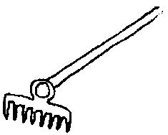________________________________________________________

1. Give one danger of mosquitoes to people.

___________________________________________________________________

1. How can people kill germs in water?

____________________________________________________________________

1. Which food value do we get from eating honey?

__________________________________________________________________

1. How useful is a father at home.

__________________________________________________________________

1. What is meant by the term germination?

__________________________________________________________________

__________________________________________________________________

1. How is burning similar to rusting?

____________________________________________________________________

__________________________________________________________________

1. Name any one wood fuel used at home.

____________________________________________________________________

1. Give a reason why people apply manure in the garden.

____________________________________________________________________

1. How are canine teeth important to a cat?

__________________________________________________________________

1. Write any one accident that is likely to occur to people in the kitchen.

____________________________________________________________________

1. Of what use are health parades at home?

____________________________________________________________________

**Below is a life cycle of a certain insect. Use the given illustrations to answer question 17.**

Eggs

Adult

**Y**

1. Name the stage of development illustrated with letter **Y**.

___________________________________________________________________

1. How are trees useful in our environment?

____________________________________________________________________

1. Name any one crop growing practice you know.

____________________________________________________________________

1. How are green plants adapted for photosynthesis?

____________________________________________________________________

1. Give any one example of childhood disease which can be immunized.

____________________________________________________________________

1. How do monocotyledonous plants differ from dicotyledonous plants?

___________________________________________________________________

_________________________________________________________________

1. Write down the first step taken when mixing the oral rehydration solution.

____________________________________________________________________

**The diagram below shows a plant with weak stem. Use it to answer question 24 and 25.**

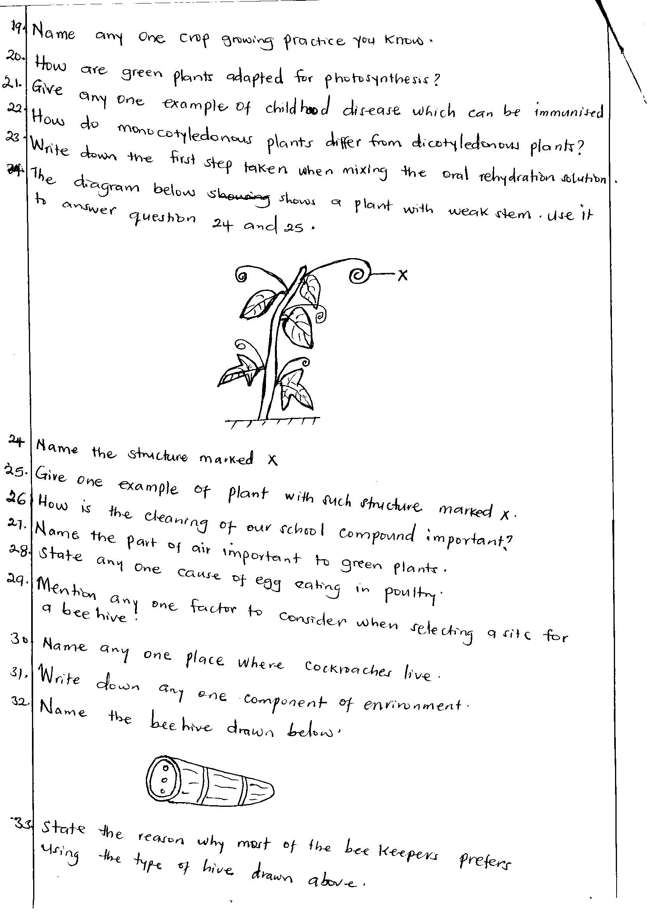

1. Name the structure marked X.

___________________________________________________________________

1. Give one example of plant with such structure marked X.

_________________________________________________________________

1. How is the cleaning of our school compound important?

_________________________________________________________________

1. Name the part of air important to green plants.

__________________________________________________________________

1. State any one cause of egg eating in poultry.

___________________________________________________________________

1. Mention any one factor to consider when selecting a site for a bee hive.

___________________________________________________________________

1. Name any one place where cockroaches live.

____________________________________________________________________

1. Write down any one component of environment.

___________________________________________________________________

1. Name the bee hive drawn below.



__________________________________________________________________

1. State the reason why most of the bee keepers prefer using the type of hive drawn above.

___________________________________________________________________

1. How are prop roots useful to a maize plant?

____________________________________________________________________

1. Why do farmers mulch their gardens?

___________________________________________________________________

1. By what process do plants absorb water and mineral salts from the soil?

___________________________________________________________________

1. How does a chameleon protect itself from enemies?

____________________________________________________________________

1. Mention any one type of rainfall you know.

____________________________________________________________________

1. Name the best food for babies.

____________________________________________________________________

1. Identify any one example of a cereal crop.

____________________________________________________________________

**SECTION B**

1. a) Give two components of air.
2. ____________________________
3. ____________________________

b) How is carbon-dioxide useful to people?

_________________________________________________________________

c) Which component of air is used by seeds to germinate?

____________________________________________________________________

1. a) What are poultry?

____________________________________________________________________

__________________________________________________________________

b) Give any one system of keeping poultry in Uganda.

__________________________________________________________________

c) Give a reason why poultry farmers hang greens in a poultry house.

____________________________________________________________________

d) Name the type of chicken which is kept for egg production.

____________________________________________________________________

1. a) Identify any one food stuffs which are eaten without being cooked.

____________________________________________________________________

b) Give any one danger of poor feeding to people.

__________________________________________________________________

c) How does food get contaminated?

___________________________________________________________________

1. a) Name two items people use to clean their bodies.
2. ____________________________
3. ____________________________

b) Why do people bathe?

_________________________________________________________________

c) Write down one danger of not keeping your body clean.

__________________________________________________________________

1. a) Give two breeds of rabbits kept in Uganda.
2. ____________________________
3. ____________________________

b) Name any one exotic breed of rabbits.

____________________________________________________________________

c) Name the rabbit disease that attacks poultry.

____________________________________________________________________

1. a) Give any two types of bees in a hive.

____________________________________________________________________

b) Name the special food given to a queen bee.

____________________________________________________________________

c) What is the difference between swarming and swarm in bees?

____________________________________________________________________

__________________________________________________________________

1. Use the experiment below to answer the questions that follow.

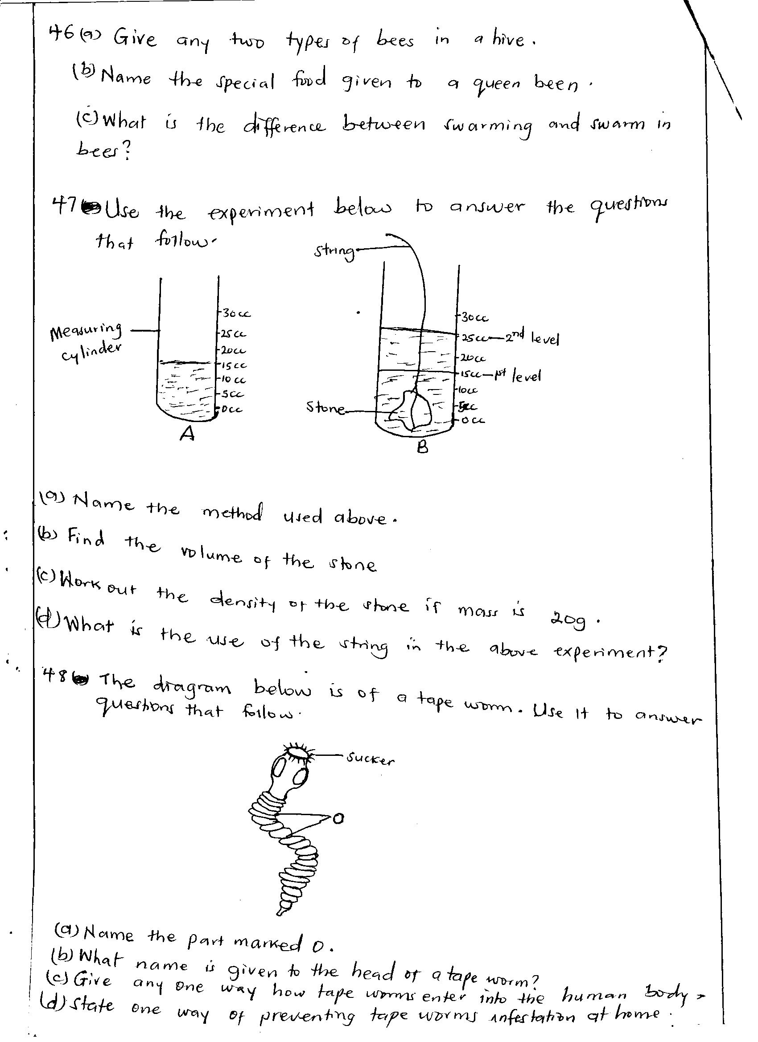 

string

stone

measuring

cylinder

**A B**

1. Name the method used below.

___________________________________________________________________

1. Find the volume of the stone.

__________________________________________________________________

1. Work out the density of the stone if mass is 20g.

____________________________________________________________________

1. What is the use of the string in the above experiment?

____________________________________________________________________

1. The diagram below is of a tape worm. Use it to answer questions that follow.



**sucker**

1. Name the part marked O.

____________________________________________________________________

1. What name is given to the head of a tape worm?

__________________________________________________________________

1. Give any one way how tape worms enter into the human body.

___________________________________________________________________

1. State one way of preventing tape worms infestation at home.

____________________________________________________________________

1. a) What is pollination?

____________________________________________________________________

__________________________________________________________________

b) What type of pollination is shown in the diagram below?

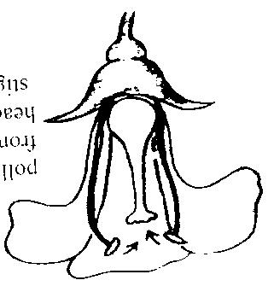__________________________________________________

c) Give one characteristic of insect pollinated flowers.

____________________________________________________________________

d) Name one living agent of pollination.

____________________________________________________________________

1. a) What is vegetative propagation?

____________________________________________________________________

b) Give one example of planting materials.

____________________________________________________________________

c) How are the following plants propagated?

1. Cassava _____________________________________________________
2. Pineapple ___________________________________________________
3. a) How do we call the condition when the body does not have enough water and mineral salts?

____________________________________________________________________

b) Write down one mineral salt lost during dehydration.

___________________________________________________________________

c) Give a reason why a dehydrated person should be given ORS?

____________________________________________________________________

d) How is salt useful when preparing ORS?

____________________________________________________________________

1. a) What are floating objects?

__________________________________________________________________

___________________________________________________________________

b) Name any two examples of floating objects.

1. ____________________________
2. ____________________________

c) Give a reason why objects float on water.

____________________________________________________________________

1. a) What is weather?

___________________________________________________________________

___________________________________________________________________

b) Write down any two elements of weather you know.

1. _________________________________________________________________
2. _________________________________________________________________

c) How can a farmer manage changes caused by rainy weather in his/her garden?

___________________________________________________________________

1. a) Who is a casualty?

___________________________________________________________________

_________________________________________________________________

b) State any two causes of road accidents in Uganda.

1. __________________________________________________________________
2. __________________________________________________________________

c) How is first aid different from an accident?

____________________________________________________________________

____________________________________________________________________

1. a) Name any two PIASCY messages you know.
2. _________________________________________________________________
3. _________________________________________________________________

b) Give one way in which HIV/AIDS spread.

____________________________________________________________________

c) Give any one way of caring for HIV/AIDS patients.

____________________________________________________________________

***Success***